Lab-01
Step 1: Create a New Console Application
A new .NET Console Application named RetailInventory was created using Visual Studio 2022.
Step 2: Install Required NuGet Packages
Open Tools → NuGet Package Manager → Package Manager Console and execute the following commands:
Install-Package Microsoft.EntityFrameworkCore -Version 8.0.8
Install-Package Microsoft.EntityFrameworkCore.SqlServer -Version 8.0.8
Install-Package Microsoft.EntityFrameworkCore.Design -Version 8.0.8
Purpose of Packages
Package | Purpose
Microsoft.EntityFrameworkCore | Provides the core Entity Framework functionality.
Microsoft.EntityFrameworkCore.SqlServer | Enables EF Core to connect with SQL Server.
Microsoft.EntityFrameworkCore.Design | Supports design-time features such as migrations and scaffolding.
Step 3: Project Structure
RetailInventory
│
├── Models
│ ├── Category.cs
│ └── Product.cs
│
├── AppDbContext.cs
├── Program.cs
└── RetailInventory.csproj
Step 4: Create Model Classes
Category.cs
Represents the Category table in the database.
public class Category
{
public int Id { get; set; }
public string Name { get; set; } = "";
public List<Product> Products { get; set; } = new();
}
Explanation
- Id – Primary Key
- Name – Stores the category name.
- Products – Navigation property representing the one-to-many relationship between Category and Product.
Product.cs
Represents the Product table in the database.
public class Product
{
public int Id { get; set; }
public string Name { get; set; } = "";
public decimal Price { get; set; }
public int StockQuantity { get; set; }
public int CategoryId { get; set; }
public Category Category { get; set; } = null!;
}
Explanation
- Id – Primary Key
- Name – Product Name
- Price – Product Price
- StockQuantity – Available stock
- CategoryId – Foreign Key
- Category – Navigation property to access category details.
Step 5: Create Database Context
Create AppDbContext.cs
using Microsoft.EntityFrameworkCore;
using RetailInventory.Models;
public class AppDbContext : DbContext
{
public DbSet<Product> Products { get; set; }
public DbSet<Category> Categories { get; set; }
protected override void OnConfiguring(DbContextOptionsBuilder optionsBuilder)
{
optionsBuilder.UseSqlServer(
@"Server=(localdb)\MSSQLLocalDB;Database=RetailInventoryDb;Trusted_Connection=True;"
);
}
}
Explanation
- DbContext acts as a bridge between the application and SQL Server.
- DbSet<Product> maps the Product class to the Product table.
- DbSet<Category> maps the Category class to the Category table.
- UseSqlServer() configures the SQL Server database connection.
Step 6: Connection String
@"Server=(localdb)\MSSQLLocalDB;
Database=RetailInventoryDb;
Trusted_Connection=True;"
Connection Details
Property | Description
Server | SQL Server LocalDB Instance
Database | RetailInventoryDb
Trusted_Connection=True | Uses Windows Authentication
Step 7: Program.cs
using Microsoft.EntityFrameworkCore;
using RetailInventory;
using RetailInventory.Models;
using var context = new AppDbContext();
context.Database.EnsureCreated();
if (!context.Categories.Any())
{
var electronics = new Category
{
Name = "Electronics"
};
var product = new Product
{
Name = "Laptop",
Price = 55000,
StockQuantity = 10,
Category = electronics
};
context.Products.Add(product);
context.SaveChanges();
}
var products = context.Products
.Include(p => p.Category)
.ToList();
foreach (var p in products)
{
Console.WriteLine($"Product: {p.Name}, Category: {p.Category.Name}, Price: {p.Price}, Stock: {p.StockQuantity}");
}
Step 8: How the Code Works
Create Database
context.Database.EnsureCreated();
Creates the database automatically if it does not already exist.
Create Category
var electronics = new Category
{
Name = "Electronics"
};
Creates a new category object.
Create Product
var product = new Product
{
Name = "Laptop",
Price = 55000,
StockQuantity = 10,
Category = electronics
};
Creates a new product and associates it with the Electronics category.
Add Data
context.Products.Add(product);
Adds the product object to the Entity Framework context.
Save Data
context.SaveChanges();
Saves all changes to the SQL Server database.
Retrieve Data
context.Products
.Include(p => p.Category)
.ToList();
Retrieves all products along with their related category details.
Display Output
Console.WriteLine($"Product: {p.Name}, Category: {p.Category.Name}, Price: {p.Price}, Stock: {p.StockQuantity}");
Displays the product information in the console.
How Everything is Connected
Category.cs
↓
Product.cs
↓
AppDbContext.cs
↓
SQL Server LocalDB
↓
Program.cs
↓
Console Output
Output
Product: Laptop, Category: Electronics, Price: 55000.00, Stock: 10
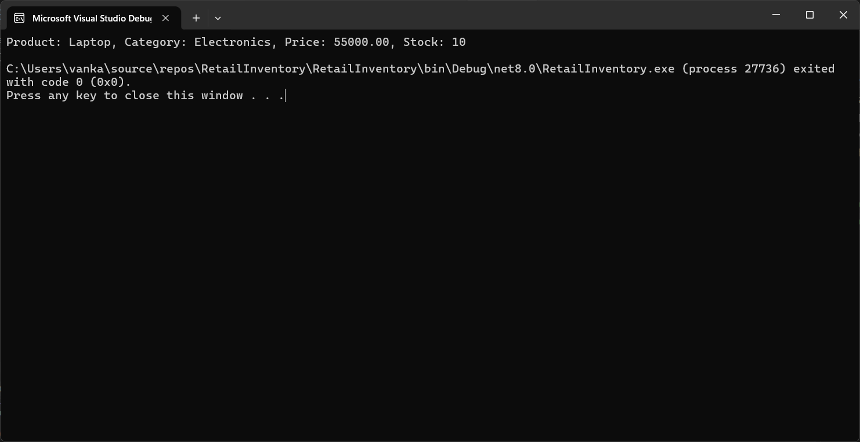

Lab 2: Setting Up the Database Context for a Retail Store
Scenario
The retail store needs to store product and category information in a SQL Server database. Entity Framework Core (EF Core) is used to establish a connection between the C# application and SQL Server using a database context (DbContext).
Objective
The objective of this lab is to configure the DbContext, establish a connection to SQL Server LocalDB, and create model classes for storing product and category information.
Software Requirements
- Visual Studio 2022
- .NET 8.0 SDK
- SQL Server LocalDB
- Entity Framework Core 8.0
- NuGet Package Manager
Project Name
RetailInventory
Step 1: Create a New Console Application
A new .NET Console Application named RetailInventory was created using Visual Studio 2022.
Step 2: Install Required NuGet Packages
Open:
Tools → NuGet Package Manager → Package Manager Console
Execute the following commands:
Install-Package Microsoft.EntityFrameworkCore -Version 8.0.8
Install-Package Microsoft.EntityFrameworkCore.SqlServer -Version 8.0.8
Install-Package Microsoft.EntityFrameworkCore.Design -Version 8.0.8
Purpose of Installed Packages
Package | Purpose
Microsoft.EntityFrameworkCore | Provides the core functionality of Entity Framework Core.
Microsoft.EntityFrameworkCore.SqlServer | Enables the application to connect to SQL Server.
Microsoft.EntityFrameworkCore.Design | Supports design-time features such as migrations and scaffolding.
Step 3: Project Structure
RetailInventory
│
├── Models
│ ├── Category.cs
│ └── Product.cs
│
├── AppDbContext.cs
├── Program.cs
└── RetailInventory.csproj
Step 4: Create Model Classes
Category.cs
namespace RetailInventory.Models
{
public class Category
{
public int Id { get; set; }
public string Name { get; set; } = "";
public List<Product> Products { get; set; } = new();
}
}
Explanation
- Id – Primary Key of the Category table.
- Name – Stores the category name.
- Products – Navigation property representing the one-to-many relationship between Category and Product.

Product.cs
namespace RetailInventory.Models
{
public class Product
{
public int Id { get; set; }
public string Name { get; set; } = "";
public decimal Price { get; set; }
public int StockQuantity { get; set; }
public int CategoryId { get; set; }
public Category Category { get; set; } = null!;
}
}
Explanation
- Id – Primary Key of the Product table.
- Name – Stores the product name.
- Price – Stores the product price.
- StockQuantity – Stores the available stock.
- CategoryId – Foreign Key that links the product to the Category table.
- Category – Navigation property used to access category information.
Step 5: Create AppDbContext
A class named AppDbContext was created by inheriting from the DbContext class. It acts as the bridge between the C# application and SQL Server.
using Microsoft.EntityFrameworkCore;
using RetailInventory.Models;
namespace RetailInventory
{
public class AppDbContext : DbContext
{
public DbSet<Product> Products { get; set; }
public DbSet<Category> Categories { get; set; }
protected override void OnConfiguring(DbContextOptionsBuilder optionsBuilder)
{
optionsBuilder.UseSqlServer(
@"Server=(localdb)\MSSQLLocalDB;
Database=RetailInventoryDb;
Trusted_Connection=True;");
}
}
}
Explanation
- DbContext manages the database connection.
- DbSet<Product> maps the Product class to the Products table.
- DbSet<Category> maps the Category class to the Categories table.
- UseSqlServer() configures the SQL Server connection using the connection string.
Step 6: Configure SQL Server Connection
The SQL Server connection string was configured inside the OnConfiguring() method.
@"Server=(localdb)\MSSQLLocalDB;
Database=RetailInventoryDb;
Trusted_Connection=True;"
Connection Details
Property | Description
Server | Connects to SQL Server LocalDB
Database | Creates or connects to the RetailInventoryDb database
Trusted_Connection=True | Uses Windows Authentication
Step 7: Test the Database Connection
The Program.cs file was updated to create the database, insert sample data, and retrieve the stored records.
using Microsoft.EntityFrameworkCore;
using RetailInventory;
using RetailInventory.Models;
using var context = new AppDbContext();
context.Database.EnsureCreated();
if (!context.Categories.Any())
{
var category = new Category
{
Name = "Electronics"
};
var product = new Product
{
Name = "Laptop",
Price = 55000,
StockQuantity = 10,
Category = category
};
context.Products.Add(product);
context.SaveChanges();
}
var products = context.Products
.Include(p => p.Category)
.ToList();
foreach (var p in products)
{
Console.WriteLine($"Product: {p.Name}, Category: {p.Category.Name}, Price: {p.Price}, Stock: {p.StockQuantity}");
}
Explanation
- EnsureCreated() creates the database if it does not exist.
- Add() adds a new product to the EF Core context.
- SaveChanges() stores the data in SQL Server.
- Include() retrieves the related Category data.
- ToList() fetches all product records.
- Console.WriteLine() displays the retrieved data.
Step 8: Build and Run the Application
- Build the project using Build → Rebuild Solution.
- Run the application using Ctrl + F5.
- EF Core connects to SQL Server LocalDB.
- The RetailInventoryDb database is created (if it does not already exist).
- Product and Category data are inserted into the database.
- The inserted records are retrieved and displayed in the console.
How the Application Connects to SQL Server
Category.cs + Product.cs
│
▼
AppDbContext.cs
│
▼
UseSqlServer(Connection String)
│
▼
SQL Server LocalDB
│
▼
RetailInventoryDb
│
▼
Program.cs
│
▼
Console Output
Output
Product: Laptop, Category: Electronics, Price: 55000.00, Stock: 10
Result
The AppDbContext was successfully configured to connect the application with SQL Server LocalDB using Entity Framework Core. The Product and Category classes were mapped to database tables through DbSet, and the application successfully created the database, inserted sample data, retrieved the records using LINQ, and displayed the output in the console.
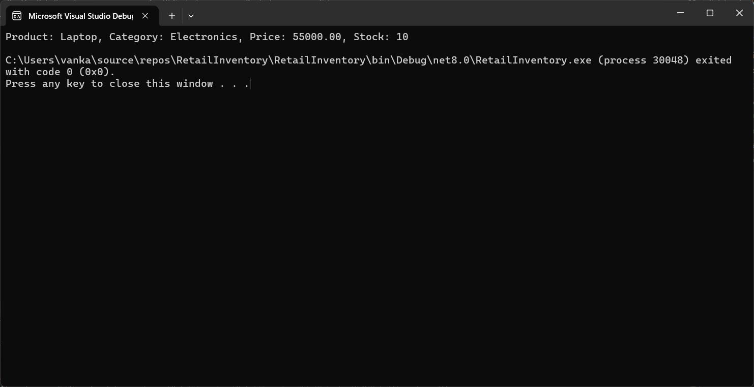

Lab 3: Using EF Core CLI to Create and Apply Migrations
Scenario
The retail store database needs to be created based on the model classes defined in the project. EF Core migrations are used to generate and apply database schema changes.
Objective
The objective of this lab is to use EF Core migration commands to create the database and tables from the C# model classes.
Project Name
RetailInventory
Implementation
Step 1: Installed Required EF Core Packages
The following packages were installed in the project:
Install-Package Microsoft.EntityFrameworkCore -Version 8.0.8
Install-Package Microsoft.EntityFrameworkCore.SqlServer -Version 8.0.8
Install-Package Microsoft.EntityFrameworkCore.Design -Version 8.0.8
Install-Package Microsoft.EntityFrameworkCore.Tools -Version 8.0.8
Step 2: Category.cs
namespace RetailInventory.Models
{
public class Category
{
public int Id { get; set; }
public string Name { get; set; } = "";
public List<Product> Products { get; set; } = new();
}
}
Step 3: Product.cs
namespace RetailInventory.Models
{
public class Product
{
public int Id { get; set; }
public string Name { get; set; } = "";
public decimal Price { get; set; }
public int StockQuantity { get; set; }
public int CategoryId { get; set; }
public Category Category { get; set; } = null!;
}
}
Step 4: AppDbContext.cs
using Microsoft.EntityFrameworkCore;
using RetailInventory.Models;
namespace RetailInventory
{
public class AppDbContext : DbContext
{
public DbSet<Product> Products { get; set; }
public DbSet<Category> Categories { get; set; }
protected override void OnConfiguring(DbContextOptionsBuilder optionsBuilder)
{
optionsBuilder.UseSqlServer(
@"Server=(localdb)\MSSQLLocalDB;Database=RetailInventoryDb;Trusted_Connection=True;"
);
}
}
}
Step 5: Program.cs
using Microsoft.EntityFrameworkCore;
using RetailInventory;
using RetailInventory.Models;
using var context = new AppDbContext();
if (!context.Categories.Any())
{
var category = new Category
{
Name = "Electronics"
};
var product = new Product
{
Name = "Laptop",
Price = 55000,
StockQuantity = 10,
Category = category
};
context.Products.Add(product);
context.SaveChanges();
}
var products = context.Products
.Include(p => p.Category)
.ToList();
foreach (var p in products)
{
Console.WriteLine($"Product: {p.Name}, Category: {p.Category.Name}, Price: {p.Price}, Stock: {p.StockQuantity}");
}
Step 6: Build the Project
The project was rebuilt using:
Build → Rebuild Solution
The build was successful.
Step 7: Create Initial Migration
In Visual Studio, the Package Manager Console was opened using:
Tools → NuGet Package Manager → Package Manager Console
The following command was executed:
Add-Migration InitialCreate
This command created a Migrations folder in the project. The migration file contains schema information for creating the Categories and Products tables.
Step 8: Apply Migration to Database
The following command was executed:
Update-Database
This command applied the migration and created the database schema in SQL Server LocalDB.
Step 9: Handling Existing Database Issue
Since the database was previously created using EnsureCreated(), the following error occurred:
There is already an object named 'Categories' in the database.
To fix this issue, the old database was removed using:
Drop-Database
After confirmation, the migration was applied again:
Update-Database
Step 10: Database Created
After applying the migration, EF Core created the database:
RetailInventoryDb
The following tables were created:
Categories
Products
Step 11: Run the Application
The application was executed using:
Ctrl + F5
Output
Product: Laptop, Category: Electronics, Price: 55000.00, Stock: 10
Result
EF Core migrations were successfully used to create and apply the database schema. The migration generated the required database structure based on the model classes. The database RetailInventoryDb was created in SQL Server LocalDB with Products and Categories tables. The application successfully inserted and retrieved data from the database.

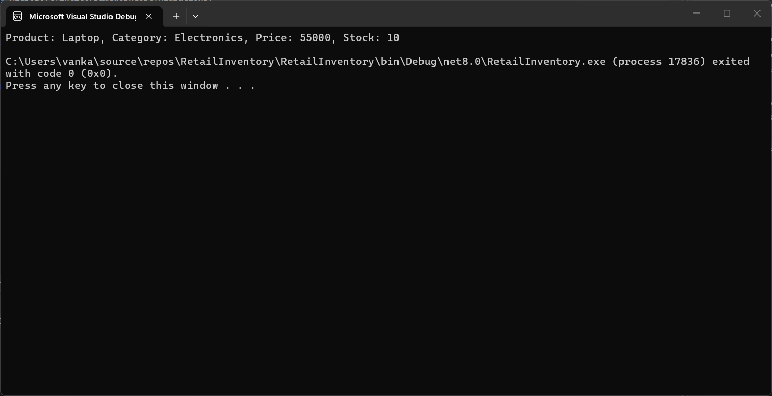

Lab 4: Inserting Initial Data into the Database
Scenario
The retail store manager wants to add initial product categories and products to the system. Entity Framework Core is used to insert the initial records into the SQL Server database asynchronously.
Objective
To use EF Core asynchronous methods AddRangeAsync() and SaveChangesAsync() to insert initial data into the database.
Project Name
RetailInventory
Implementation
Step 1: Open the Existing Project
Continue with the existing RetailInventory project created in the previous labs.
Step 2: Verify Model Classes
Ensure the following model classes already exist:
- Category.cs
- Product.cs
These classes represent the Categories and Products tables in SQL Server.
Step 3: Verify Database Context
Ensure AppDbContext.cs is already configured with SQL Server LocalDB.
using Microsoft.EntityFrameworkCore;
using RetailInventory.Models;
namespace RetailInventory
{
public class AppDbContext : DbContext
{
public DbSet<Product> Products { get; set; }
public DbSet<Category> Categories { get; set; }
protected override void OnConfiguring(DbContextOptionsBuilder optionsBuilder)
{
optionsBuilder.UseSqlServer(
@"Server=(localdb)\MSSQLLocalDB;Database=RetailInventoryDb;Trusted_Connection=True;");
}
}
}
Step 4: Update Program.cs
Replace the contents of Program.cs with the following code.
using Microsoft.EntityFrameworkCore;
using RetailInventory;
using RetailInventory.Models;
using var context = new AppDbContext();
if (!await context.Categories.AnyAsync())
{
var electronics = new Category
{
Name = "Electronics"
};
var groceries = new Category
{
Name = "Groceries"
};
await context.Categories.AddRangeAsync(electronics, groceries);
var product1 = new Product
{
Name = "Laptop",
Price = 75000,
StockQuantity = 10,
Category = electronics
};
var product2 = new Product
{
Name = "Rice Bag",
Price = 1200,
StockQuantity = 25,
Category = groceries
};
await context.Products.AddRangeAsync(product1, product2);
await context.SaveChangesAsync();
Console.WriteLine("Initial data inserted successfully!");
}
var products = await context.Products
.Include(p => p.Category)
.ToListAsync();
foreach (var p in products)
{
Console.WriteLine($"Product: {p.Name}, Category: {p.Category.Name}, Price: {p.Price}, Stock: {p.StockQuantity}");
}
Step 5: Build the Project
Build the application by selecting:
Build → Rebuild Solution
Ensure the build completes successfully without errors.
Step 6: Run the Application
Execute the application using:
Ctrl + F5
The application connects to SQL Server, checks whether category records already exist, inserts the initial categories and products asynchronously, saves them into the database, and retrieves the inserted records.
Step 7: Verify the Database
Open SQL Server Management Studio (SSMS).
Connect to:
(localdb)\MSSQLLocalDB
Open:
Databases
↓
RetailInventoryDb
↓
Tables
Verify that:
- Categories table contains:
  - Electronics
  - Groceries
- Products table contains:
  - Laptop
  - Rice Bag
Expected Output
Initial data inserted successfully!
Product: Laptop, Category: Electronics, Price: 75000.00, Stock: 10
Product: Rice Bag, Category: Groceries, Price: 1200.00, Stock: 25
Result
The initial category and product records were successfully inserted into the SQL Server database using Entity Framework Core asynchronous methods AddRangeAsync() and SaveChangesAsync(). The data was successfully retrieved using LINQ and displayed in the console, demonstrating asynchronous database operations in EF Core.
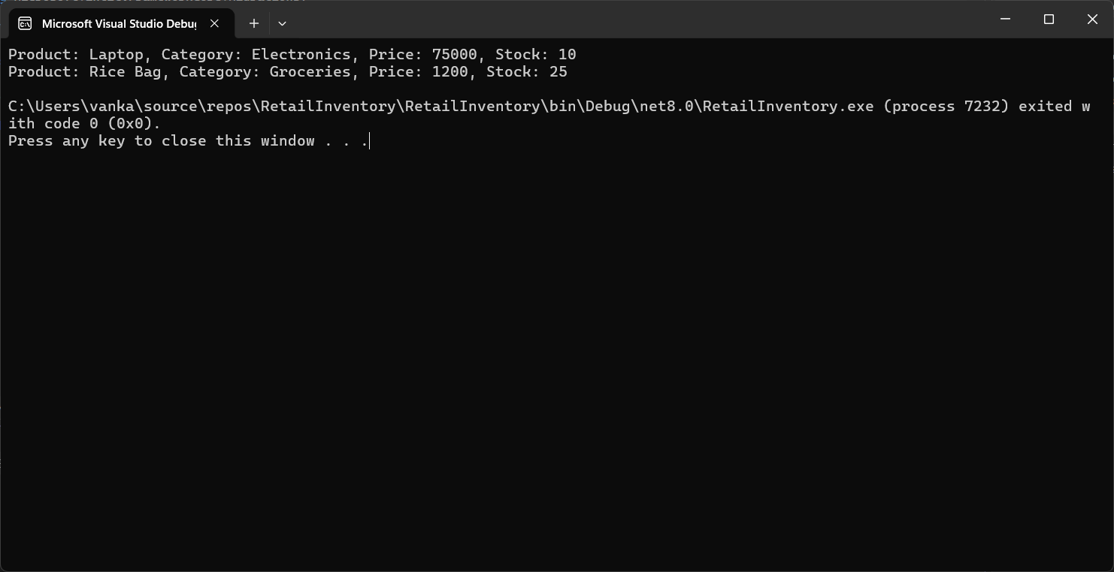

Lab 5: Retrieving Data from the Database
Implementation
Step 1: Open the Existing Project
Continue using the existing RetailInventory project created in the previous labs.
Step 2: Verify Database
Ensure that the RetailInventoryDb database contains the product records inserted in Lab 4.
Step 3: Retrieve All Products
Open Program.cs and use the ToListAsync() method to retrieve all product records from the Products table.
var products = await context.Products.ToListAsync();
foreach (var p in products)
{
Console.WriteLine($"{p.Name} - ₹{p.Price}");
}
Explanation:
- ToListAsync() retrieves all records from the Products table asynchronously.
- foreach is used to display each product's name and price.

Step 4: Retrieve a Product by ID
Use the FindAsync() method to retrieve a product using its primary key.
var product = await context.Products.FindAsync(1);
Console.WriteLine($"Found: {product?.Name}");
Explanation:
- FindAsync(1) searches for the product whose Id = 1.
- If the product exists, its name is displayed.

Step 5: Retrieve the First Product Matching a Condition
Use the FirstOrDefaultAsync() method to retrieve the first product whose price is greater than ₹50,000.
var expensive = await context.Products
.FirstOrDefaultAsync(p => p.Price > 50000);
Console.WriteLine($"Expensive: {expensive?.Name}");
Explanation:
- FirstOrDefaultAsync() returns the first record that satisfies the given condition.
- If no matching record exists, it returns null.

Step 6: Build the Project
Build the application using:
Build → Rebuild Solution
Ensure the project builds successfully.

Step 7: Run the Application
Run the application using:
Ctrl + F5

Expected Output
All Products:
Laptop - ₹75000.00
Rice Bag - ₹1200.00
Found: Laptop
Expensive: Laptop

Result
The application successfully retrieved data from the SQL Server database using Entity Framework Core asynchronous query methods. The ToListAsync() method was used to retrieve all products, FindAsync() was used to search by primary key, and FirstOrDefaultAsync() was used to retrieve the first record matching a specified condition.

